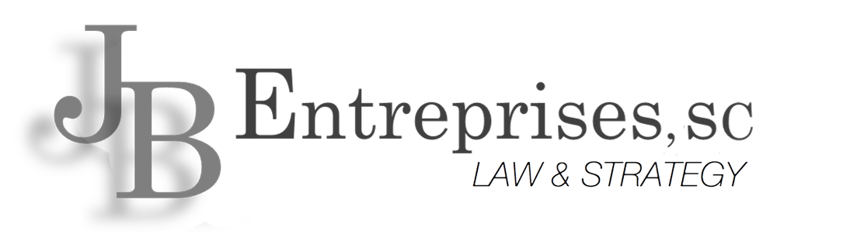

|  |  |
| --- | --- |
| 6 August 2021 | **Abia Harper**  414.763.5952  abia.harper@jbentreprises.com |

**Via Email (*disastercustomerservice@sba.gov)***

Small Business Administration

310 W. Wisconsin Ave #580 W

Milwaukee, WI 53203

Re: **Marketing Letter – Compliance & Legal Services**

Dear SBA,

My name is Abia Harper and I am the Marketing Administer of JB Entreprises, Law & Strategy.

Thank you for considering JB Entreprises as your legal consultant. Our firm has a long-standing

History of being a concierge to our clients as we provide an array of various legal services. With

over 25 years of experience in business compliance and governmental regulation, as well as

over 18 years of legal defense practice, JB Entreprises S.C. Law & Strategy was founded in

2007 with the hope of connecting with small businesses, accommodating with those small

businesses, while also developing the next generation of attorneys. We have accomplished and

continue to do just that.

Our firm has primarily been a resource for the small to midsize businesses because we believe

every small business deserves high quality counsel and expert representation. Cost should not be

a barrier to permitting businesses from growing without fear of permits, ordinances, regulatory

compliance or audits. In doing so, JB Entreprises advises businesses on how to integrate

compliance requirements into their own workflows avoiding failing compliance audits, agency

investigations, and legal actions.

We have serviced many industries ranging from but not limited to: CBRF Facilities, restaurants,

government transfer businesses, mental health clinics, banking, construction and real estate

development. With our ever-growing portfolio of clients, for years we have provided the help

they need by offering our Corporate Counsel Division, our Civil Litigation Division and our

Criminal Defense Division as advisors and advocates. Our management team has restructured

and developed the organization to reflect not only growth, but the future potential of investment

of its legal staff to become partners and shareholders and since 2017, we are successful in doing

so and have experienced a pattern of growth.

By developing additional community partners, JB Entreprises can further fulfill its mission of

making sure other successful businesses do not merely focus on profit, but instead balance

compliance with economic empowerment. We protect businesses against harmful threats,

whether they be from vendors, competitors, contractors, consumers or harmful government

regulations at customized monthly retainer rates so you can better manage your legal cost. JB

Entreprises is committed to excellence and to the success of our clients, providing dedicated and

focused services, one client at a time. We invite you to contact our office to further discuss your

legal needs and how our firm may be able to assist you in protecting all that you have

accomplished & achieved.

If you have any questions, comments or concerns, please do not hesitate to contact our office.

Very Truly Yours,

JB ENTREPRISES, S.C.

*/s/ Abia Harper*

Abia Harper

*Marketing Administer*

ATH/np